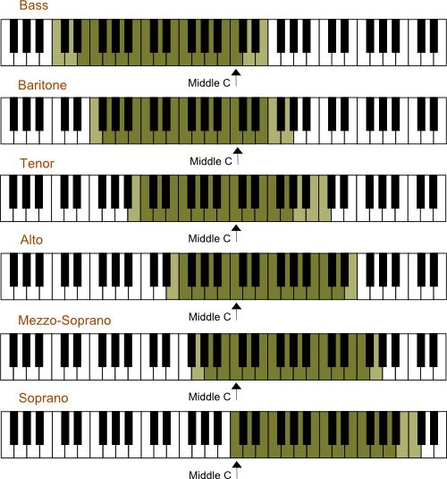
FIND YOUR VOCAL RANGE! Name: ____________________________________

Above, you see the approximate ranges for each voice part in the choir. Your range might vary slightly, but try to find and label which one is yours.

HIGHEST NOTE: ________

LOWEST NOTE: _________

The middle of your range where you feel the most comfortable is called your TESSITURA. This “comfort zone” encompasses the span of about a perfect 5th (5 white keys on the piano). Find your Tessitura.

TESSITURA LOW NOTE: ________

TESSITURA HIGH NOTE: ________

